Project Plan – Travelling Salesman Problem
Nick van der Merwe – s5151332 1810ICT : Software Development Processes

Introduction
This document aims to set a plan for completing a Travelling Salesman Problem solver with a Simulated Annealing algorithm. This will be done in three parts: part A, where the algorithm is made, part B, where the database is made and part C where the graphical interface is made. To manage time, a work breakdown structure, activity definition and Gantt chart is made in this project plan.

Work Breakdown Structure
This section contains deliverable orientated diagrams of what is required for each part.

Part A
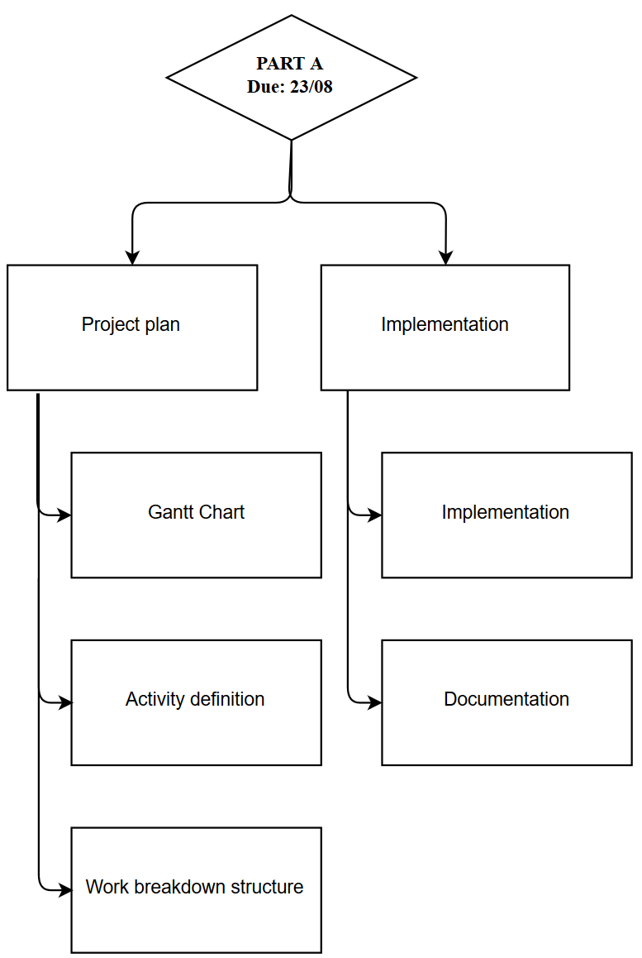

Part B

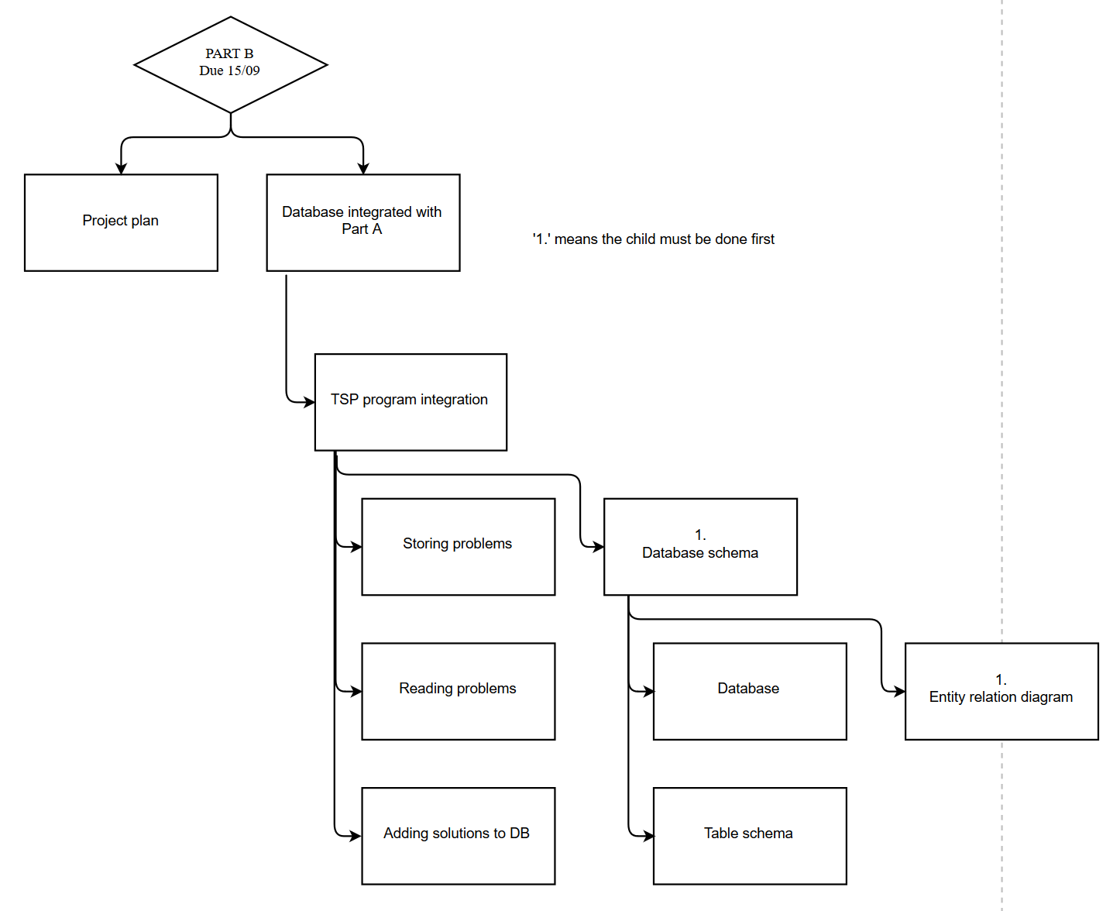

Part C 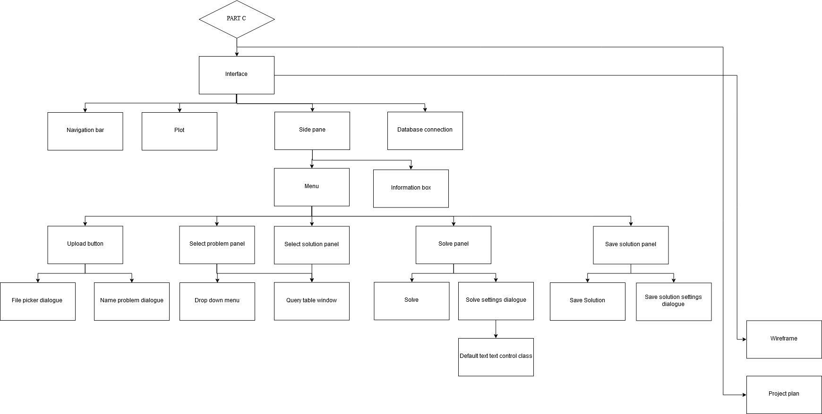

Activity Definition
Here the objects in work breakdown structure are defined and a length estimate is set.
Part A:
- Work breakdown structure – 2 hours: Read assignment to make activity definitions & work breakdown structure
- Activity definition - 20mins: Explicitly define each task in the work breakdown structure
- Initial Gantt Chart – 2 hours: Copy from WBS and activity definition (done at the same time in first half)
- Documentation – 2 hours: First write up initial research then record logic as implementation goes
- Implementation – 10 hours: making the algorithm: 4 hours of research and initial logic and 6 hours of programming
Part B:
- Project plan – 1 hour: Update project plan to match new task sheet
- Entity relation diagram – 1 hour; structure of the database
- Database – 40mins; write the code to generate the schema of the database
- Table schema – 10mins; generate a table schema from the database code using PyCharm
- Database integration to Python program – 5 hours
  - Adding problems – 2 hours: adding problems to the database
  - Reading – 2 hours: reading a file from the database
  - Storing solutions – 1 hours: storing solutions in the database
PART C
- Project plan – 1 hour: Update project plan to match task sheet changes
- Wireframe – 2 hours: Create a wireframe; shows all the parts of the interface
- Database connection – 2 hours: Change Project B’s code such that it works with the shared database
- Interface – All sub hours + splitter window to adjust spaces (30mins)
  - Plot – 1 hour: Configure scalability and draw() function through matplotlib
  - Navigation bar – 20mins: Attach a navigation bar to the matplotlib
  - Side pane: 20mins + sub deliverables: Connect sub deliverables and create splitter so its adjustable
    - Information box – 1 hour: Static text with functions to show information on all situations
    - Menu (continued in next section)
As the menu sections gets nested quite deeply its split into its own section for readability:
MENU:
- Upload button: 20mins + sub: Connect sub deliverables & make sure they both close if the first closes
  - File picker dialogue: 30mins – implement a dialogue that brings up the OS’s picker
  - Name problem dialogue: 20mins – implement a dialogue to pick a name (includes checking if the name connects
- Select problem panel (same sub deliverables as solution panel): 30mins: Customise sub classes to show problem names and Problem table
- Select solution panel – 30mins + sub: Customise sub classes to show Solution ID and length and Solution table
  - Drop down menu: 20mins: Class that queries the database and generates a dropdown menu showing essential information; loads solution when selected; disabled when problem isn’t selected
  - Query table window: 2 hours: Class that makes a wxFrame that shows all the information from a given query
- Solve panel – 10mins + sub: Connect sub deliverables with buttons
  - Solve - 20mins: Create button that runs the solve command and separate solve/save solution in DB code
  - Solve settings dialogue – 1 hour: Button the launches class which prompts running time and algorithm to use with radio buttons
- Save solution panel – 10mins + sub: connect sub deliverables into a panel & scale
  - Save solution – 20mins: Button that saves the solution; edit database class to do it separately
  - Save solution settings – 30mins: Generate dialogue that prompts for author name
    - Default text control class – 30mins: Create a text control class that has a ‘default text mode’ when its clicked off to show what the previous authorship name was before changing it

Gantt Chart
As the menu’s nesting is so deep and the activities are smaller it was put onto its own Gantt chart:
Main Gantt Chart (1 period = 1 hour)
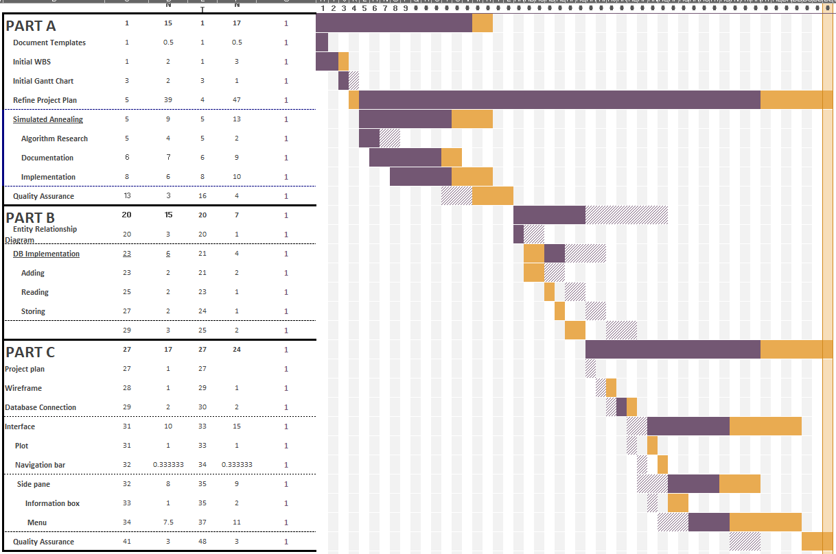
Menu Gantt chart ( 1 period = 30mins)
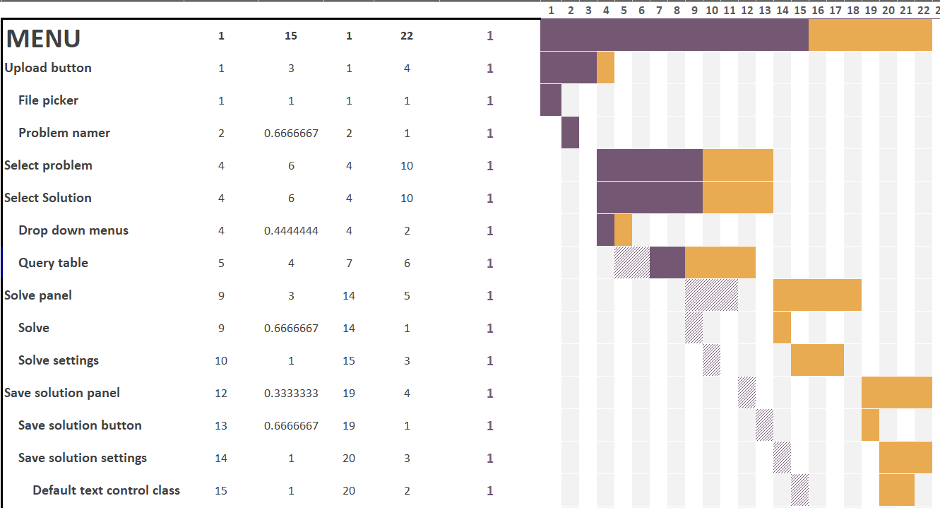
Fun fact: this project would’ve costed 946.5AUD at minimum wage! (50 hours * 18.93)

